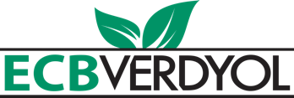

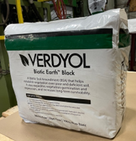

Verdyol Biotic Earth™ Black Specification Template

Hello, Thank you for grabbing a copy of our Verdyol Biotic Earth™ Black Specification Template

Below you will find three variations of specifications ready to incorporate into your next project documentation.
Feel free to copy, paste, and modify as necessary. Should you require any additional details or assistance, please don't hesitate to reach out via phone or email.
Best regards,
Alex Zimmerman
Email: alex@ecb.ca
Phone: 1-360-910-4800

#1 - Product Specification:

Verdyol Biotic Earth Black is specifically designed to assist in the creation of a suitable growth medium for establishing vegetation over poor and deficient soil. It is also designed to speed up the vegetation establishment and full expression, as well as increases the survivability of vegetation where used. This product is designed for hydraulic application, but dry application (hand spreading) is also acceptable.

For Use on Sites Where:
- Soil tests show less than 5% organic material
- Where topsoil intended for revegetation has been stockpiled for extended periods or is of less than ideal quality
- As a replacement for compost or other soil improvement methods
- Steep slopes or other site conditions make installation of topsoil or compost difficult
- Where fast establishment of vegetation is required

*** Please note:
Verdyol Biotic Earth Black is a soil improvement product so an adequate and separate erosion control product (RECP, TRM, or Hydraulic) is recommended for site protection.

Performance Properties
Vegetation Establishment and Germination Improvement | ASTM D7322* | % | 1502%
Average Plant Height | ASTM D7322* | % | 308%
Plant Mass per Area | ASTM D7322* | % | 419%
Material and Environmental Properties
Organic Material | ASTM D586 | % | >95
Water Holding Capacity | ASTM D7367 | % | 1020%
pH | Saturated Media Extract Method | n/a | 6 +/- 1
C:N Ratio | Independent laboratory | n/a | 35:1 (+/- 10)
Natural Material Color (Dye Free) | Observed | n/a | Dark Brown/ Black
Moisture Content | Independent laboratory | % | 30.50%
Acute Toxicity | EPA TM 2002.0 | na | 100% Non Toxic
Foreign Seed Content | Viability Analysis | % | 0%
Product Composition
Professional Grade Peat Moss |  | % | 57%
Thermally and Mechanically Processed Straw and Flexible Flax Fiber |  | % | 40%
Trace Minerals, Plant Based Biodegradeable co-polymer, sugars, starches, proteins, and 16 amno acids (including folic acid, vitamin A, and tricontanol growth stimulants/ regulators) |  | % | 2%
Multiple Species of Both Mycorrhizae and Beneficial Bacteria |  | % | 1%
Material Viability
Biotic Earth moisture content ensures microbial viability in excess of 75% for two years from date of manufacture.
Packaging Properties
Bag Weight | Scale | kg (lb.) | 22.7 (50)
Bags per Pallet | Observed | # | 42
UV and weather resistant bags. Pallets are weather proof stretch wrapped with a UV resistant pallet cover. Dates on manufacture listed per bag
*percentages are the average of 7, 14, and 21 day results of ASTM D7322
To the best of our knowledge the information contained herein is accurate. However, ECBVerdyol cannot assume any liability whatsoever for the accuracy or completeness thereof.

#2 - Product Citation Materials specific specification:

- Mulch

XX. Hydraulic Growth Medium and Biodegradable Growth Medium Method
Mulch shall be biotic-active hydraulically applied mulch such as ‘Verdyol Biotic Black Earth Black’, or an approved equal. Any approved equal must include the following material composition:

Material Composition:
40% by volume of thermally and mechanically processed straw and flexible flax fibers
57% by volume of professional grade sphagnum peat moss
1.26% by volume other valuable tracer minerals, sugars, starches, proteins, fiber and 16 amino acids including folic acid, Vitamin A, triaconnatol growth stimulants/regulators
1% by volume mycorrhizae

Laboratory Analysis:
Total Organic Matter Content = >95%
Carbon: Nitrogen Ratio = 31:1
Moisture Content = 44.5% +/- 5%
pH = 5.5 (Saturated Media Extract Method)

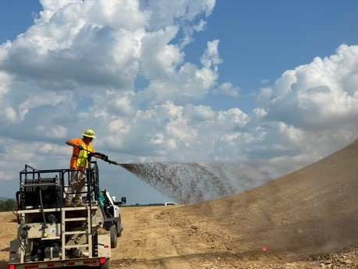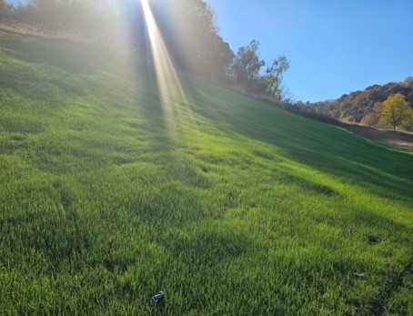

#3 - Materials specific specification:

Soil Amendment
Soil amendment shall be a pre-packaged, commercially available, hydraulically applied blend of natural fibers, mycorrhiza, growth stimulants, and other biologically active material designed to improve seed germination and vegetation establishment.

Soil amendment shall be manufactured from thermally and mechanically processed straw and flexible flax fibers, sphagnum peat moss and other biological additives at the following volumes:

- 35-45% by volume of thermally and mechanically processed straw and flax fibers
- 50-60% by volume of professional grade sphagnum peat moss
- 1-2% by volume of other biological additives including trace minerals, sugars, starches, proteins, folic acid, vitamin A, triaconnatol and triacontanol growth stimulants/regulators
- <1% by volume of fungal mycorrhiza and plant beneficial bacteria

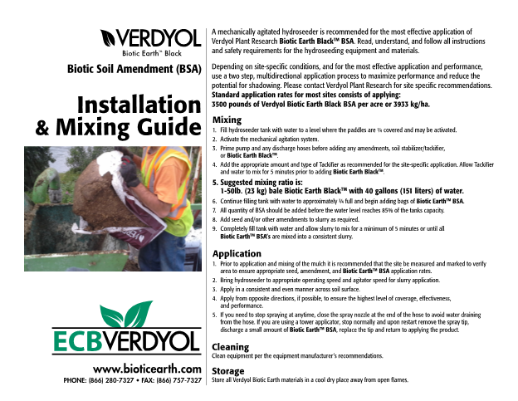

Please note:
that our mixing instructions recommend 40 gallons of water per bag, it is acceptable if the contractor uses less gallons per bag. The limitation is the size and power of the hydroseeder being used.

Verdyol Biotic Earth can also be hand applied in situations that warrant that application. If Hand application is used then we recommend tripling the amount used per acre so that coverage can be achieved on the soil surface.

*Disclaimer*
To the best of our knowledge the information contained herein is accurate - however, ECBVerdyol cannot assume any liability whatsoever for the accuracy or completeness thereof.

